SimpliLearn Kubernetes Notes

Contents

Introduction 3

Overview 3

Kubernetes Architecture 5

Kubernetes Cluster 7

Building Containers in Docker 7

Kubernetes Objects 7

Kubernetes Components 8

Pod 8

Deployment 9

NameSpace 10

Service 10

Necessity of Service 12

Create NakedPod 12

Service + Deployment 14

Kubernetes Dashboard 16

Kubernetes Security 17

Create Roles 18

Bind Roles to User 19

Multi-Container Pods 20

Workload 22

Multi-Container Pods 23

Init Containers 23

DaemonSet 24

Jobs 25

Scale-Up and Scale-Down 26

AutoScaling 27

Liveness and Readiness Probes 28

ETCD 29

Rollout/Rollback Changes 31

Rollout 31

Rollback 32

Multi-Tier Application Deployment 33

StaticPod 34

Scheduler Policies 35

Resource Quota 36

NodeSelector 36

NodeAffinity 37

PriorityClass 38

Networking 39

Networking Components 40

ingress vs egress 42

Multiport-Service 43

Security 43

SecurityContext 43

NetworkPolicy 44

DenyFromOtherNamespaces 44

Kubernetes Vulnerabilities Management 45

Container Security 46

Platform Security 46

Demo 46

Storage 47

Persistent Storage 47

Sharing Data 48

Secrets in Volume 48

More about Storage 49

Upgrade Kubernetes 50

Upgrade into master 51

Worker Node 53

Setup in GCP Account 53

# Introduction

Trainer Name – Karthick [aps.karthick@gmail.com](mailto:aps.karthick@gmail.com)

<https://www.onemodel.app/d/5dp9laP9F4mdPTJBf7v1O> - Presentation

<https://docs.google.com/document/d/1Z69OZ_470-hPWr4FnX3fOZ3rCTEOup4Hvwzdp-4Dnhs/edit?tab=t.0#heading=h.s0c63ij6cv05> – Job Roles

Kubernetes is written in GOLang

## Overview

Docker is container management

Kubernetes is container orchestration (Music Orchestrator is the coordinate effort takes care of all the musicians)

GitHub Link 🡪 <https://github.com/devopscert202/k8sforbeginners>

Kubernetes Install 🡪 <https://github.com/devopscert202/k8sforbeginners/blob/main/k8s/labs/installation/install.md>

Whatever packed in the container is shipped to any environment. This solves production issues deploy the code into any environment where it won’t have issues like can’t be deployed into Windows, Linux etc. Container is immutable. Container is the instance of an Image

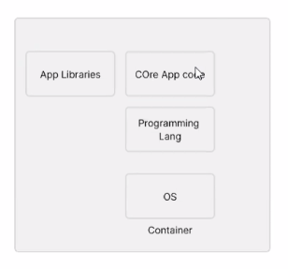

Kubernetes is responsible for shipping the container from one cloud to another cloud

Advanced Kubernetes is Anthos

Till 2019 Kubernetes was using Docker Container Runtime Interface

Kubernetes 🡪 Manage the container image

Docker 🡪 Create Image

Docker CRI 🡪 Kubernetes promoted Docker CRI and officially supported

After 2019 Docker is deprecated from major cloud providers and replaced by Containerd

YAML Basics 🡪 <https://github.com/devopscert202/k8sforbeginners/blob/main/k8s/docs/basics/yaml-basics.md>

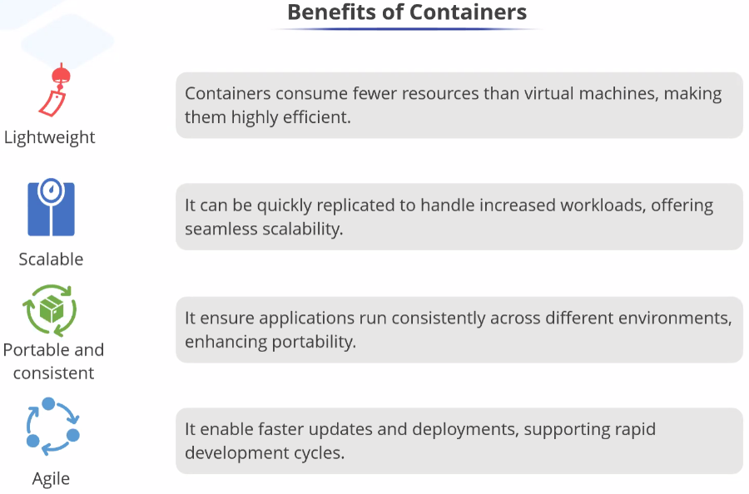

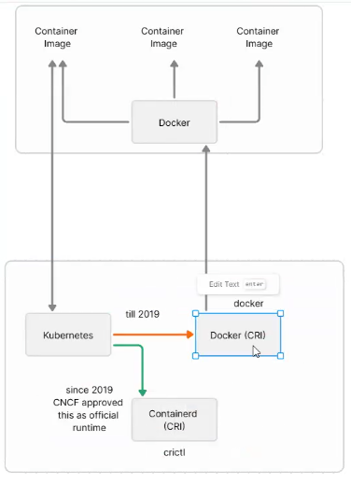

CRICTL 🡪 Container Runtime Interface CTL

## Kubernetes Architecture

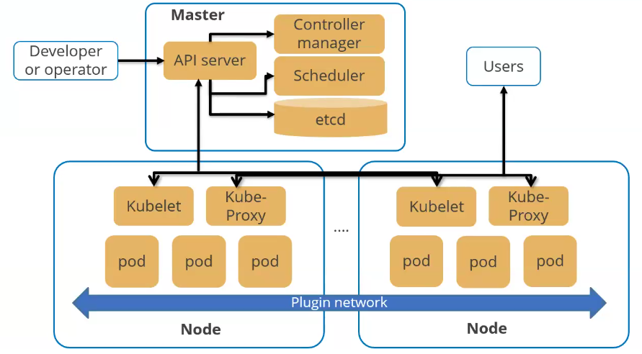

**Cluster** – Group of servers contains Master and client servers as Nodes

**Master – Control Plane or Compute Machine**

API Server **🡪** Any request is received by API Server. K8s core functionality relies. Any command invokes API Server. (Heart)

Controller Manager 🡪 Takes decisions on workloads where exactly need to contact the component on node machine to perform a task. For cloud it has cloud controller manager.

Scheduler 🡪 After getting instruction from API Server, scheduler schedules the workloads on a given node based on CPU, memory and POD Requirements

Etcd 🡪 File based key-value database. Open source DB. Has complete cluster based configuration. (Brain)

**Nodes – Data Plane**

Kubelet 🡪 Node agent. Communication happens between master and the node through kubelet.

Kube-proxy 🡪 Complete network – Workloads communicating each other, container contacting DB, one microservice contact another which is enabled by kube-proxy

Pod 🡪 minimal possible workload in node and this hosts container. Accomplishing a task. Can be QA Pod, Security Pod, development Pod (Group of people to compete a task)

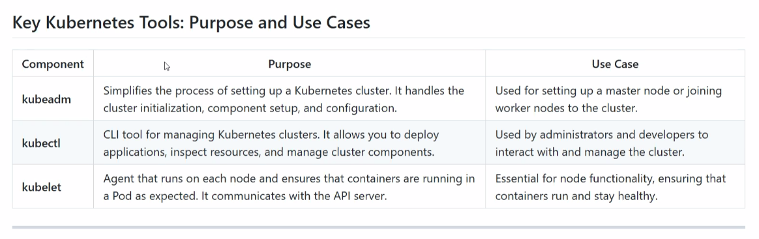

Core DNS 🡪Present in both master and nodes. Naming services are provided.

Users 🡪 Uses the application hosted.

## Kubernetes Cluster

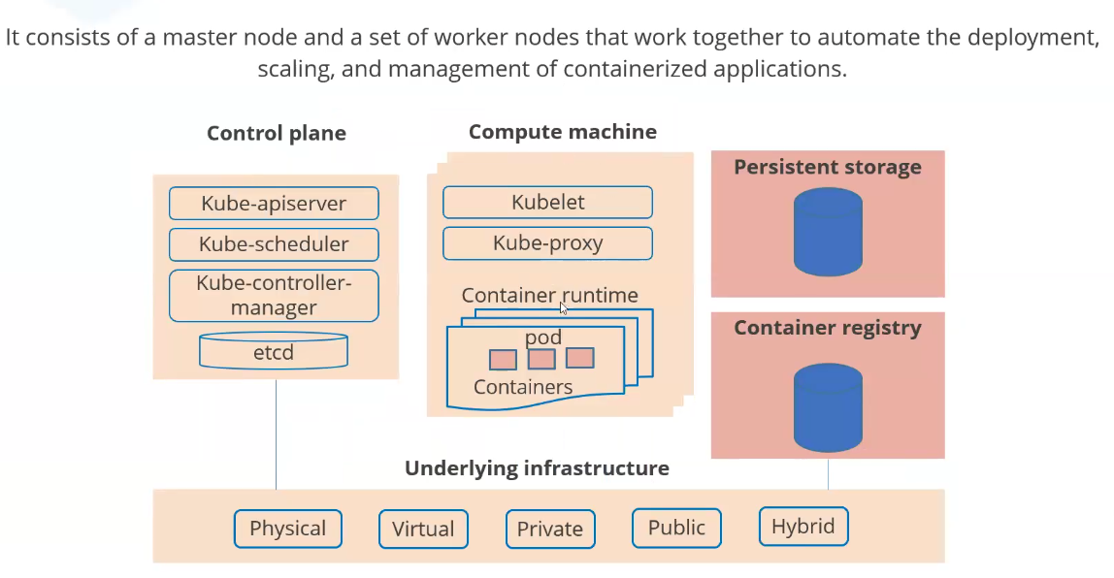

Container Runtime 🡪 Pulls the images, manage the containers, available on the worker node.

To run Kubernetes needs,

Persistent Storage 🡪 Hard disk

Container Registry 🡪 All container images are maintained (Containerd, previously Docker)

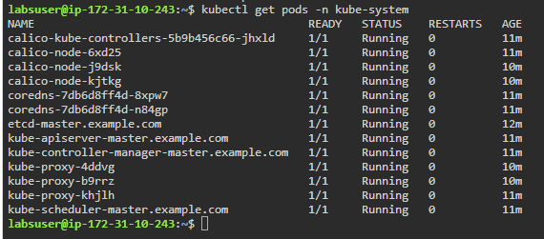

## Building Containers in Docker

Follow <https://github.com/devopscert202/k8sforbeginners/tree/main/k8s/labs/basics>

## Kubernetes Objects

<https://github.com/devopscert202/k8sforbeginners/blob/main/k8s/docs/basics/k8s-objects.md>

# Kubernetes Components

## Pod

Minimal workload/minimal deployable unit can be deployed to Kubernetes Cluster. Example a java class file.

If pod alone deployed to cluster which is a naked pod and if the pod is deployed and can’t be pulled again. So deploying like this can be used for testing purpose.

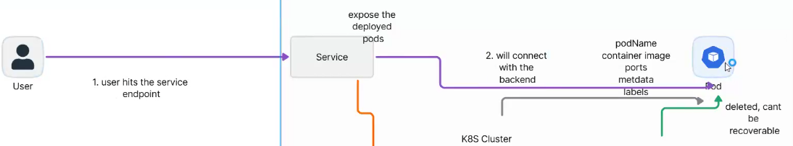

Pod consists of podName, Container image, ports, metadata, labels.

Pods can’t be accessed directly but it can be accessed only through service.

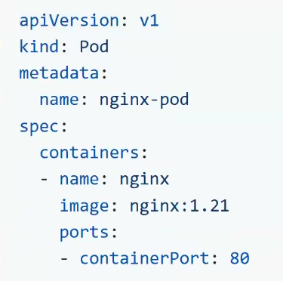

apiVersion 🡪 Instruct which version of API Server

kind 🡪 Type of the object (Here - Pod)

metadata – name 🡪 It is not container name and it is for pod name

spec – containers

name 🡪 Not image name but its container name

image 🡪 Name of the image we want to pull from docker registery

containerPort 🡪 which port want to run (its like 8080:8080 in docker compose)

Under containers there can be many container images but best practice is to have 1 container in 1 pod.

## Deployment

Whereas if we have a deployment YAML, which instructs how many pods to be available in replica.

If the replica is increased or decreased, based on the size, pods will be incremented or decremented.

If someone delete any pod, deployment will create another pod.

Deployment also consists of pods’ podName, Container image, ports, metadata, labels.

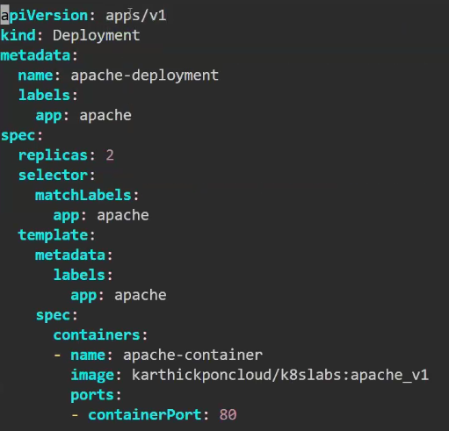

apiVersion – Takes apps/v1 from kube controller.

Metadata- name of the deployment

Spec – specification of pod

Template – docker image to be download

spec – specification of the container image

selector label is to match the label of container image label. If selector label is not matched then deployment will not deploy pod.

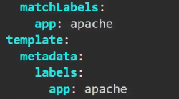

## NameSpace

Need to have 3 or more different cluster for DV, QA and PD which is costly from cloud provider, and maintaining different clusters

Kubernetes have a different approach called Namespace, where as we can keep only one cluster and can have different namespace called DV, QA and PD which are kind of objects which can be isolated from different environments. CPU, memory can be allocated for different namespace as PD namespace can consume 90% of memory

Cluster is like Harddisk and Namespace is like partition.

Stay away from default namespace.

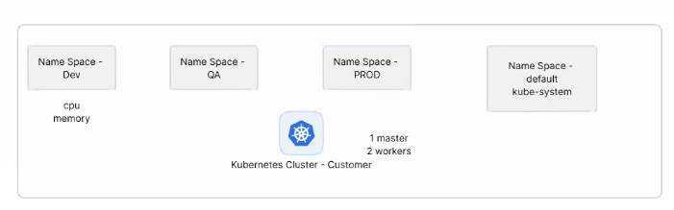

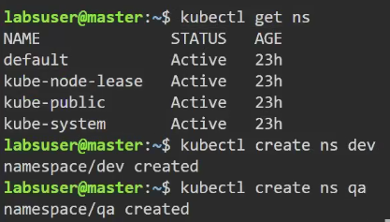

## Service

Service Expose the pods for deployment and user connect to the service and won’t connect directly to deployment or pod.

The architecture behind service, deployment and pod is the user should not be impacted if pod gets deleted.

Service will tell where to deploy the pods. Selector will scan all the pods and group them.

3 types of service which are NodePort (Node is worker node and exposing the nodes by port), LoadBalancer(Can’t use in on premise and can be used in Cloud which should have cloud controller), CluserIP (User can’t call this type directly). If not mention the type of service, it will become ClusterIP.

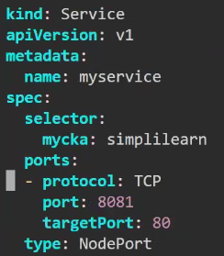

apiVersion 🡪 Are scalar variables and can be added anywhere in YAML

metadata/name – name of the service

spec

selector – at least 1 name of the pod should be matching with label (her e mycka is a name value pair). IF there are many pods in mycka, will create multiple pods

Ports

Protocol - most of the time TCP

Like in docker YAML 80:8081 – Traffic will be forwarded to container 80 port

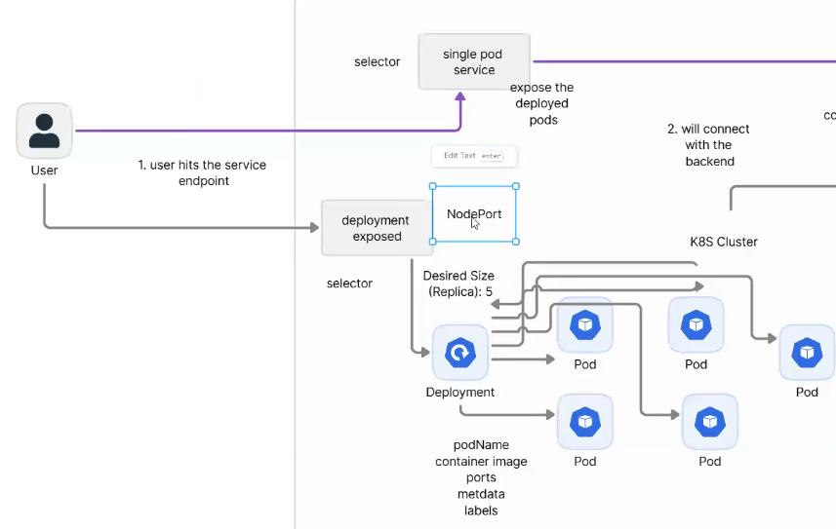

Entire communication between master, worker happen through YAML files. Entire Kubernetes are in commands and no much GUI.

<https://github.com/devopscert202/k8sforbeginners/blob/main/k8s/docs/basics/yaml-basics.md>

## Necessity of Service

### Create NakedPod

Creating a pod by name apache2 and kubectl –f apply apache2.yaml

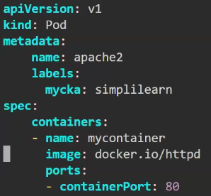

Create a service and deploy pod



selector – at least 1 name of the pod should be matching with label (her e mycka is a name value pair). IF there are many pods in mycka, will create multiple pods

In pod its in label section

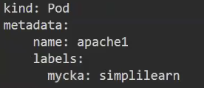

In Service its in selector section

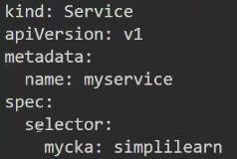

If the selector label not matching also will not give any error, since later pods may be created and kubernetes controller will monitor the change and map service with pod.

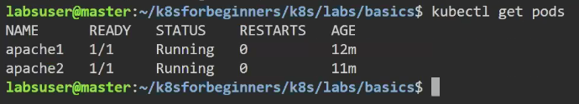



Getting list of services

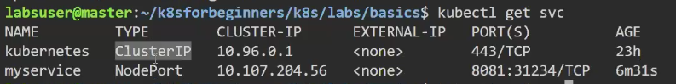

To run,



It is mentioned in the NodePort of the service. So navigating Cluster-IP IP Address and Port, able to execute the pod’s container homepage.

If we delete a pod, then not able to access from service

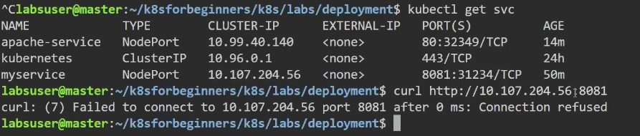

### Service + Deployment



matchLabels need to match will app label else deployment will not deploy the pod

Create a service as selector/app as apache

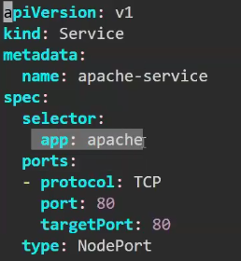

Deploy both deployment and service

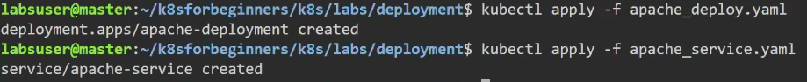



Naked pods come with pods name where as pods created from deployment has names start with apache-deployment

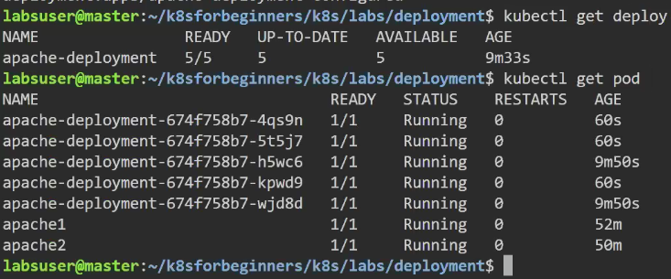

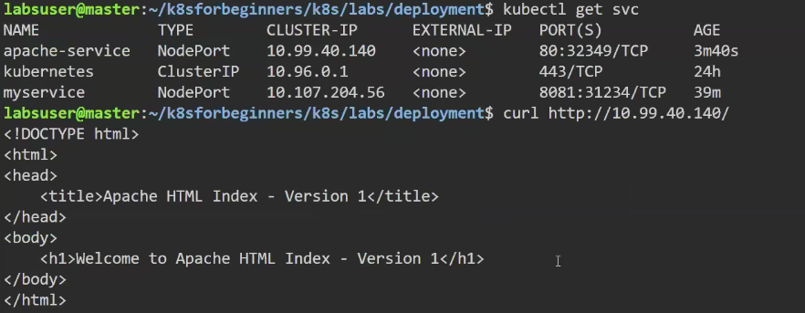

But if a pod from deployment is deleted and access the service, a new pod will be created to maintain the replica.

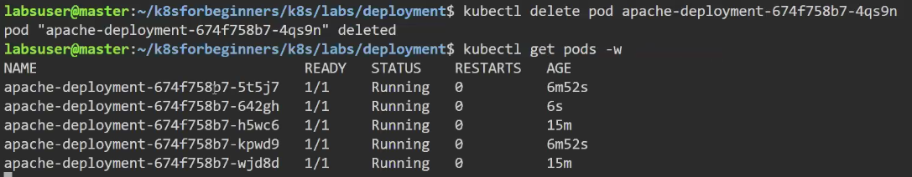

<https://kubernetes.io/docs/reference/kubectl/quick-reference/> - Quick Reference

<https://github.com/devopscert202/k8sforbeginners/blob/main/k8s/docs/basics/k8s-object-templating.md> - Templating. If there are 1000+ nodes, assigning labels to nodes is an easy way of identification. Can label nodes, deployment, service etc

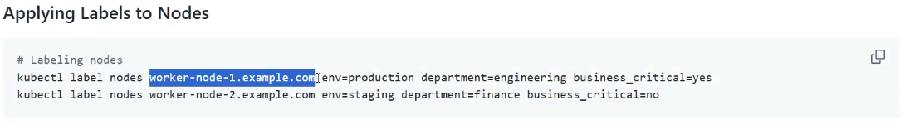

Kubectl get pods –show-labels

# Kubernetes Dashboard

<https://github.com/devopscert202/k8sforbeginners/blob/main/k8s/docs/workloads/k8s-dashboard.md>

Dashboard comes up with list of YAML files and helm can deploy all

Helm chart is bundled with commands

After the step2.3, execute the command to see if dashboard pod is created

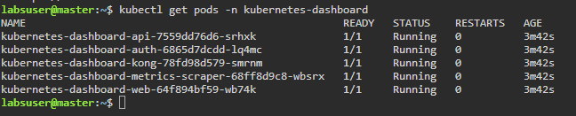

Can apply from online as well

Kubectl apply –f <https://github.com/devopscert202/k8sforbeginners/blob/main/k8s/labs/workloads/k8s-dashboard.yaml>

# Kubernetes Security

Kubernetes provides role based access

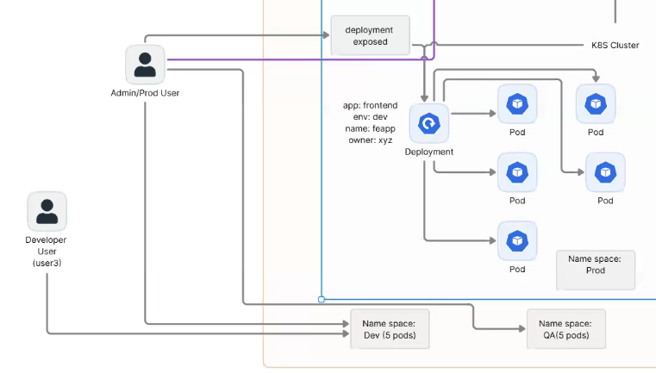

<https://github.com/devopscert202/k8sforbeginners/blob/main/k8s/docs/security/rbac-concepts.md> Role Based Access Control (RBAC) in Kubernetes

<https://github.com/devopscert202/k8sforbeginners/blob/main/k8s/docs/security/rbacdemo.md> - Demo

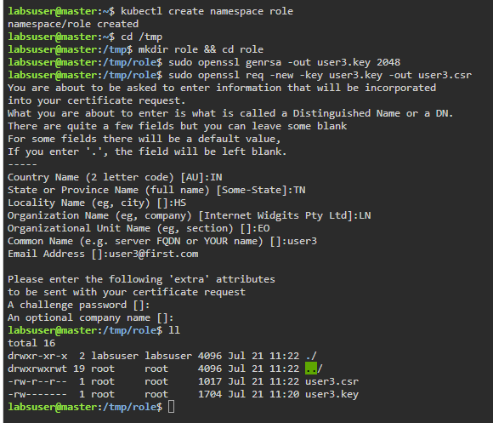

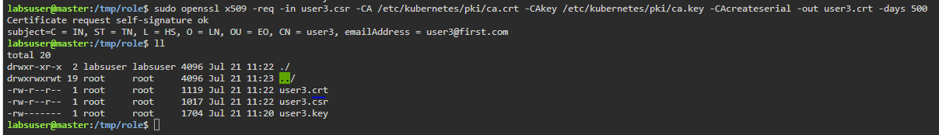

## Create Roles

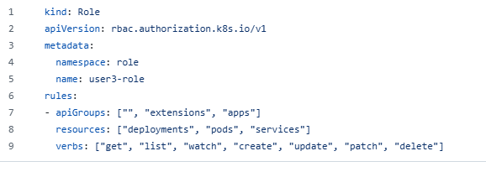

Namespace as role

Name – its created for user3

apiGroups – says what all applicable for apiVersions

resources – applicable to whether pods or deployments or services or all?

Verbs – Access to those resources





## Bind Roles to User

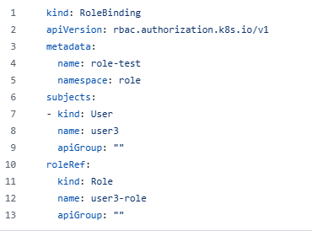

As created a role,

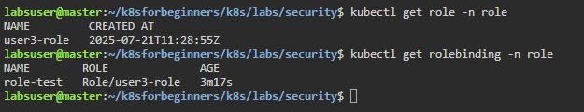

Currently admin has access to all nodes

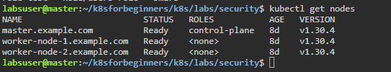



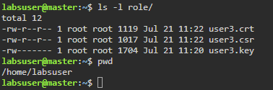

Setup context 🡪 Combination of cluster, namespace, user together. After setting, context is changed for user3 to the cluster kubernetes

Default context is kubernetes-admin@kubernetes which is mentioned as *.

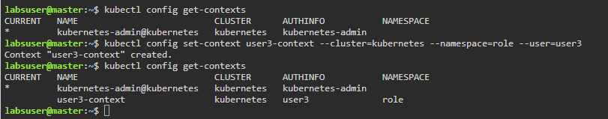

Change the context to user3 context

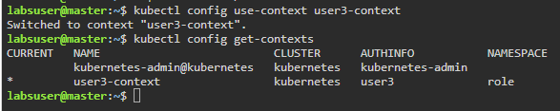

User3 don’t have access to find the default namespace.



No pods available in role namespace

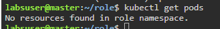

Also no nodes present to user3, and in the namespace role, can create pods, deployment and services for the user3

# Multi-Container Pods

Side car Container – 2 or more container running in a pod

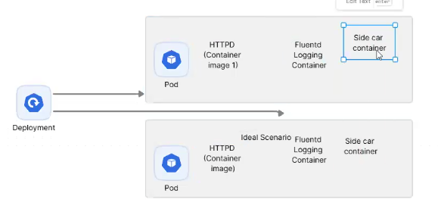

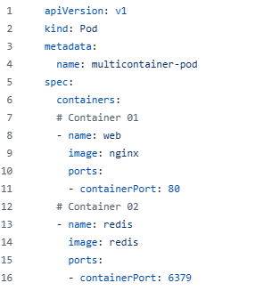

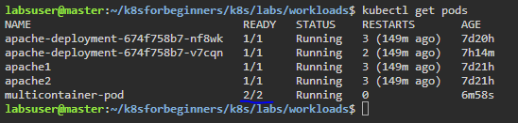

2/2 container are ready

kubectl describe pod multicontainer-pod

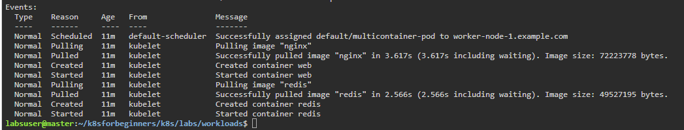

Will give more info

Kubectl get pods –o wide

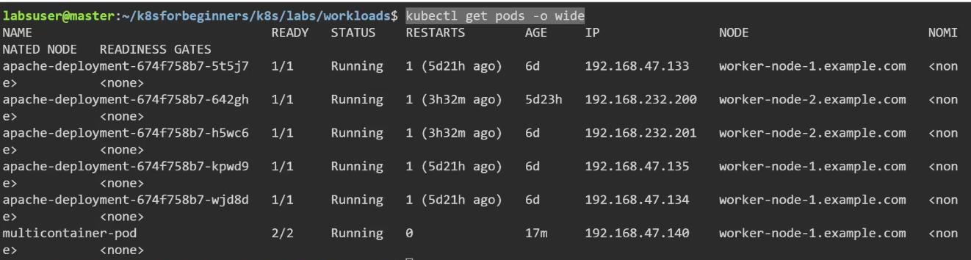

# Workload

<https://github.com/devopscert202/k8sforbeginners/blob/main/k8s/docs/workloads/>

<https://github.com/devopscert202/k8sforbeginners/blob/main/k8s/labs/workloads/>

Most of the cases workload will be supplied to worker node as most of the pods will be deployed to worker nodes.

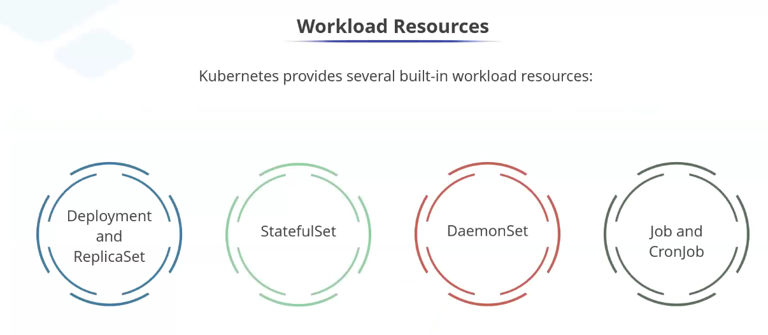

Anything to run customer business is workload. Set of compute storage network resources required to run a specific application.

<https://github.com/devopscert202/k8sforbeginners/blob/main/k8s/docs/workloads/workloads-concepts.md>

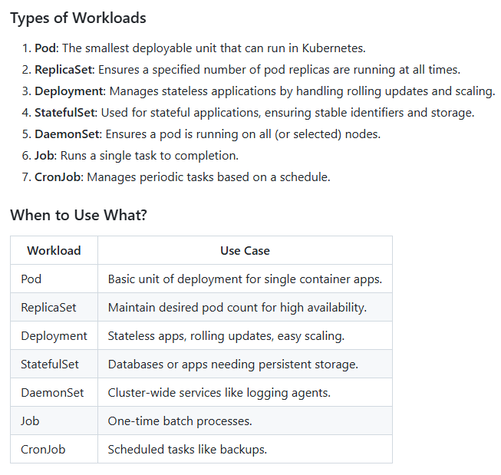

## Multi-Container Pods

Pods can host multiple containers that work together. These containers share the same network and storage resources.

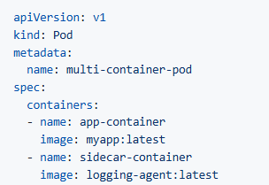

## Init Containers

Run before application container. One of the pod may be dependent on another container

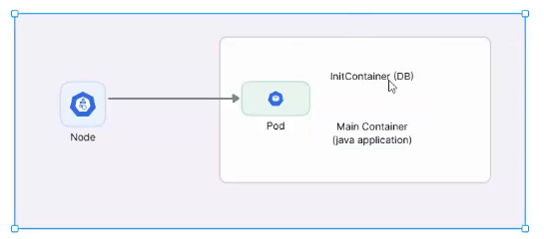

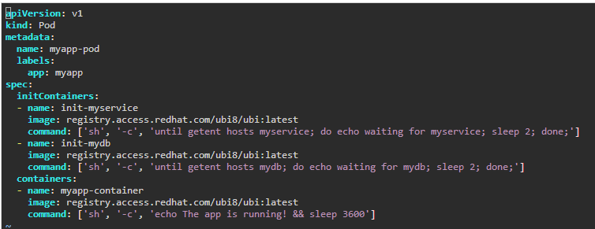

When only 1 init container is run, will show like this below

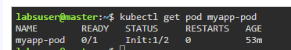

When both init container are run only the main container will run and pod will be up



kubectl describe pod myapp-pod



## DaemonSet

Deploy to all the worker nodes

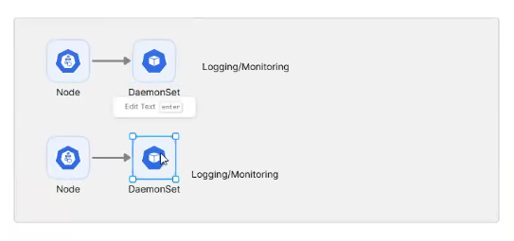

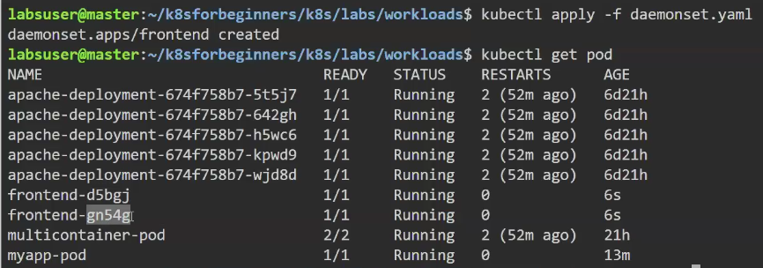



When another node is added, daemonset will be created to another node as well automatically.

All the nodes will have single daemonset and nowhere it will be more than one.

## Jobs

Once the execution of the pod is completed then it will be completed. This job calculate the value of Pi for 2000 digits.

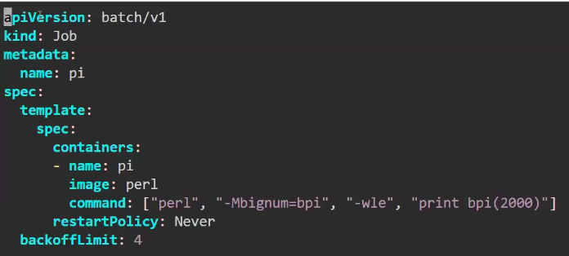

On checking the status, unless it is executed the container status will be



Once completed its execution,

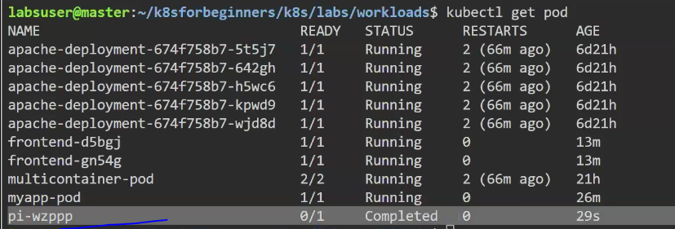

Whereas all the other pods are running.

## Scale-Up and Scale-Down

Metrics Server is an aggregator for resource usage data, such as CPU and memory, from Kubernetes nodes and pods. It provides this data via the Metrics API, which other Kubernetes tools, like kubectl top and the Horizontal Pod Autoscaler (HPA), rely on.

<https://github.com/devopscert202/k8sforbeginners/blob/main/k8s/docs/workloads/metricsserver.md>

To host into the cloud, we don’t need metrics server as AWS, Azure, GCP has it. But hosting in standalone server need to install.

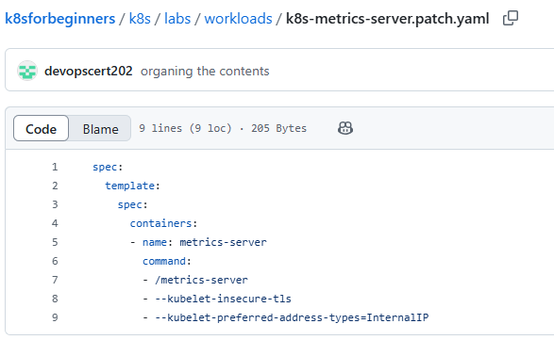

Metrics server container is used to calculate memory, CPU etc.

kubectl patch deploy metrics-server -p "$(cat k8s-metrics-server.patch.yaml)" -n kube-system

To create the pod



Since the metrics server is up and running,

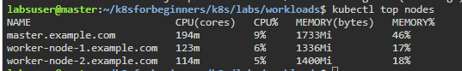

If metrics server is installed only, will get the below info.

kubectl top pods --sort-by memory

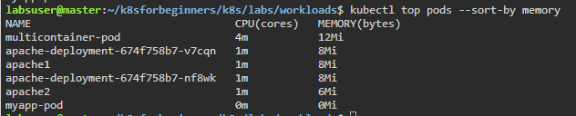

## AutoScaling

Take decisions based on the workload to handle traffic, high availability.

<https://github.com/devopscert202/k8sforbeginners/blob/main/k8s/docs/workloads/hpa.md>

<https://github.com/devopscert202/k8sforbeginners/tree/main/k8s/labs/workloads>

app-hpa.yaml – has both service and deployment

hpa.yaml – has horizontal scaler

Load Generator



If average CPU utilization is > 50%, will create another pod

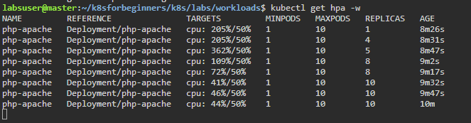

Once the load is deleted



Will reduce to 1 pod 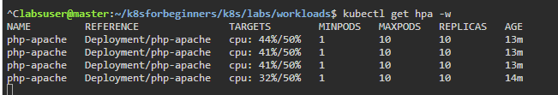

## Liveness and Readiness Probes

<https://github.com/devopscert202/k8sforbeginners/blob/main/k8s/docs/workloads/livenessprobe.md>

* **Liveness Probes:** Used to determine if a container is running. If a liveness probe fails, Kubernetes will restart the container.
* **Readiness Probes:** Used to determine if a container is ready to serve traffic. If a readiness probe fails, Kubernetes removes the Pod from the Service's endpoints until it recovers.

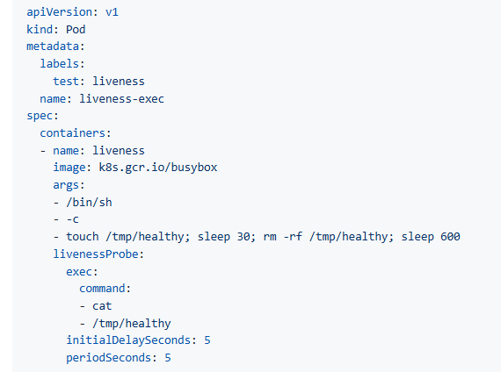

In the busybox image, will execute the touch commands, and perform all operations in the line.

livenessProbe will execute the command every 5 seconds.

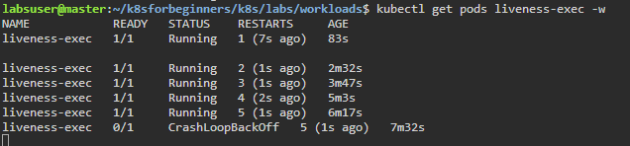

Once the probe fails it will restart the pod.

In our example we intentionally delete file in 30sec

After 5 times, it wont restart and goes to CrashLoopBackOff

On describing, will get list of events

Kubectl describe pods liveness-exec

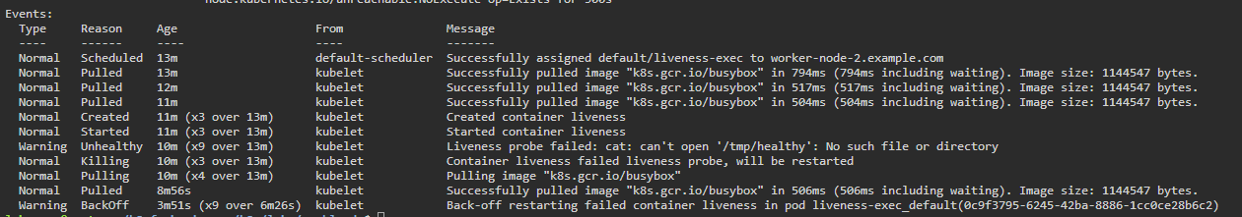

## ETCD

If etcd corrupted, then will not recover. In cloud environment don’t need to worry about etcd as cloud providers will have multiple master nodes and backup of etcd.

In standalone system, how to take backup.

Follow <https://github.com/devopscert202/k8sforbeginners/blob/main/k8s/labs/administration/etcd-backup.md> - key-value pair.

If not working

kubectl -n kube-system exec etcd-master.example.com -- etcdctl member list \ --cacert=/etc/kubernetes/pki/etcd/ca.crt \ --cert=/etc/kubernetes/pki/etcd/server.crt \ --key=/etc/kubernetes/pki/etcd/server.key

go to

sudo su –

Go to /etc/kubernetes/manifests

Vi etcd.yaml

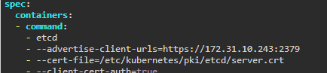

Copy <https://172.31.10.243:2379>

export advertise_url=<https://172.31.10.243:2379>

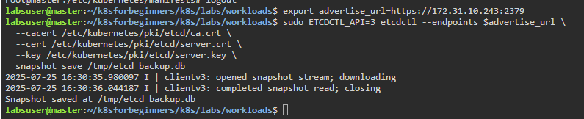



ETCDCTL_API=3 is the API version of ETCD

advertise_url – connect to db

Verification

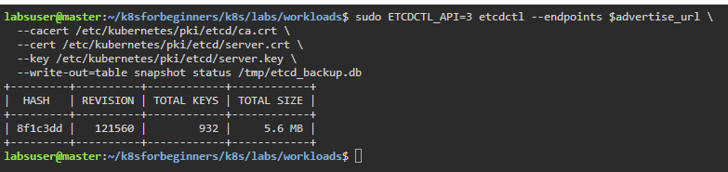

## Rollout/Rollback Changes

### Rollout

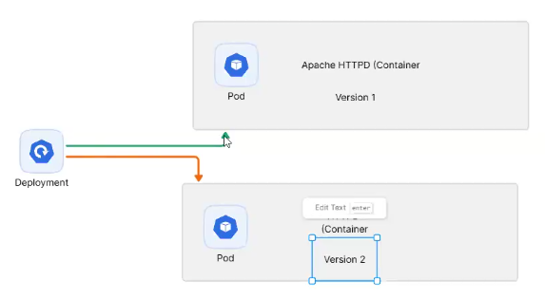

<https://github.com/devopscert202/k8sforbeginners/blob/main/k8s/docs/deployment/rollout_versions.md>

Record is maintaining the history.

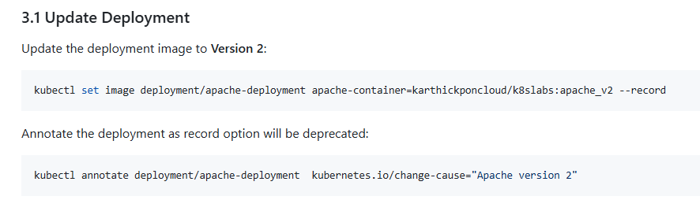

V2 version is updated



Adding more documentation



Status of deployment



On executing, curl <http://10.107.171.34> will view Version2. If any number of replica, all the pods will have same version and can control to have 50% capacity on not to kill all pods at a time as still 50% will have version 1

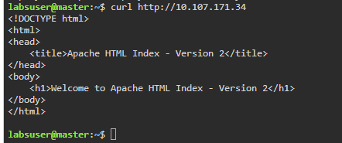

Eventhough pods were created earlier, after version2 rollout they are recreated

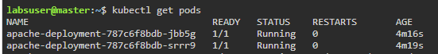

### Rollback

Finding the history of changes

kubetl annotate command did annotation into Apache Version 2 and first version don’t have annotation.

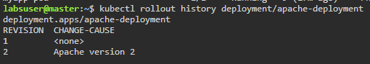

Rolled back to previous version

kubectl rollout undo deployment/apache-deployment --to-revision=1

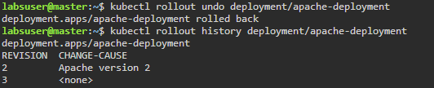

Pods got recreated

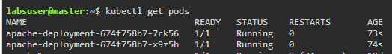

Checking the front end page, went to previous version.

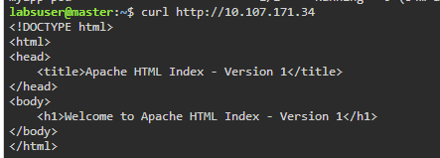

## Multi-Tier Application Deployment

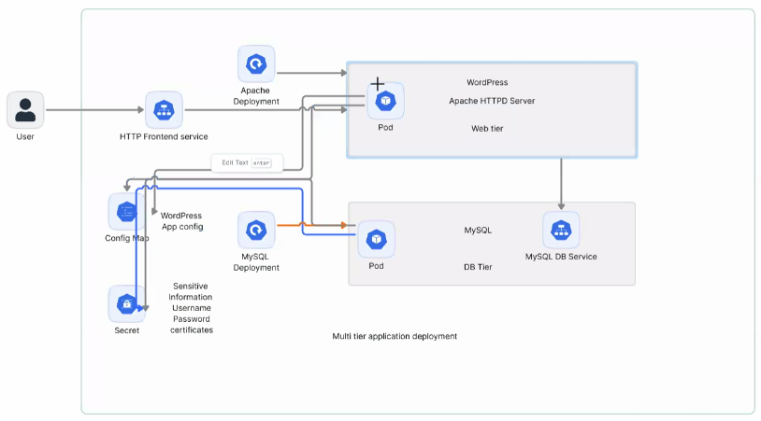

<https://github.com/devopscert202/k8sforbeginners/blob/59a13cbc243100e60a2f60c57f38231713c2a0c8/k8s/docs/workloads/wordpressonk8s.md>

For Secret, the kind will be

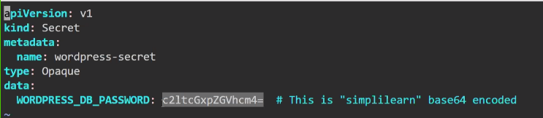

Password is encoded and kubernetes only can decode.

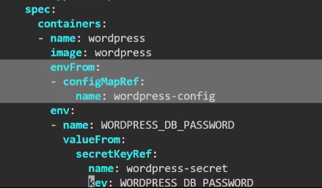

configMapRef 🡪 fetch from config map and in config map whatever names as wordpress-config will be taken

secretKeyRef 🡪 From secret file WORDPRESS_DB_PASSWORD

In this sequence,

mysql-config.yaml

mysql-secret.yaml

wordpress-configmap.yaml

wordpress-secret.yaml

mysql.yaml

wordpress.yaml

mysql-service.yaml

wordpress-service.yaml

## StaticPod

Container is deployed into any worker node.



Won’t get restarted

Go to the worker node under the location /etc/kubernetes/manifests and copy the yaml file

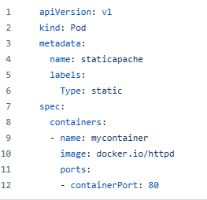

In the master node on having kubectl get pods,



Podname-workernode name.

# Scheduler Policies

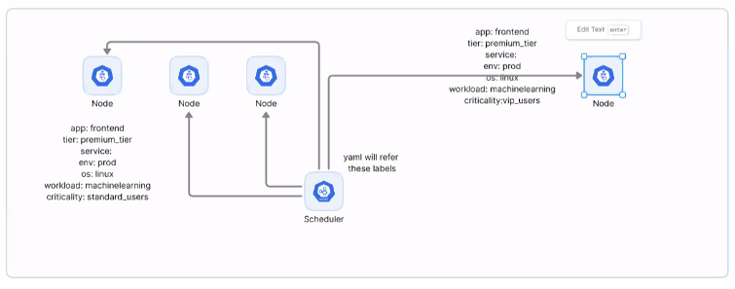

<https://github.com/devopscert202/k8sforbeginners/blob/59a13cbc243100e60a2f60c57f38231713c2a0c8/k8s/docs/basics/k8s-object-templating.md>

<https://github.com/devopscert202/k8sforbeginners/tree/59a13cbc243100e60a2f60c57f38231713c2a0c8/k8s/docs/scheduling>

<https://github.com/devopscert202/k8sforbeginners/tree/59a13cbc243100e60a2f60c57f38231713c2a0c8/k8s/labs/scheduling>

Labelling the nodes and ask the scheduler to pick from specific node for a particular label or criticality.

If none of the label is matched, then workload will not be executed and will be in pending status.



Kubectl get nodes --show-labels

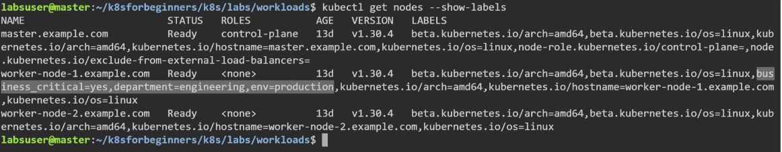

To remove label.



## Resource Quota

<https://github.com/devopscert202/k8sforbeginners/blob/59a13cbc243100e60a2f60c57f38231713c2a0c8/k8s/docs/workloads/resourcequota.md>

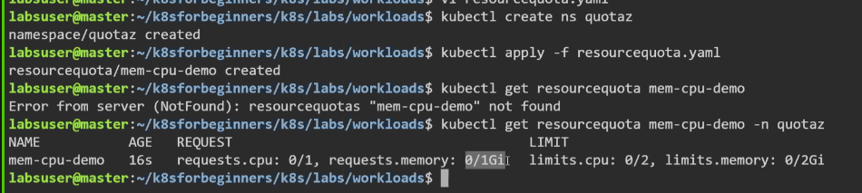

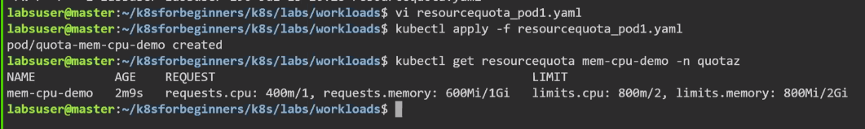



## NodeSelector

<https://github.com/devopscert202/k8sforbeginners/blob/59a13cbc243100e60a2f60c57f38231713c2a0c8/k8s/docs/scheduling/nodeselector.md>

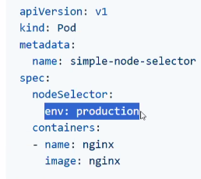

Where all env label is production, this pod will be deployed

IF no node is present will display as



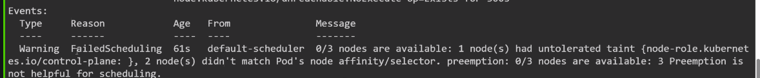

When a node is labelled, then



If unlabelled, it keeps running as for existing pod won’t happen but if a new pod then will not work.

## NodeAffinity

More flexible way of scheduling workloads.

<https://github.com/devopscert202/k8sforbeginners/blob/59a13cbc243100e60a2f60c57f38231713c2a0c8/k8s/docs/scheduling/nodeselector.md#2-using-nodeaffinity>

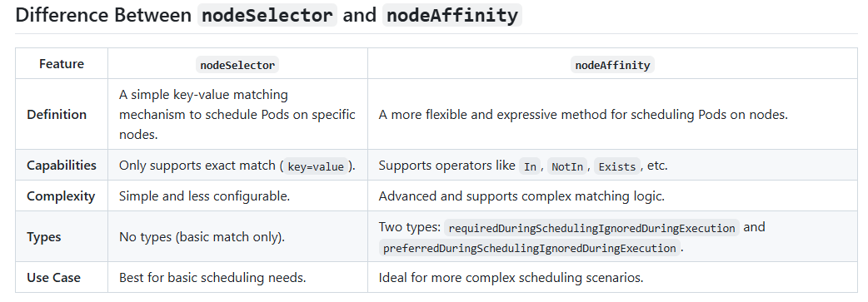

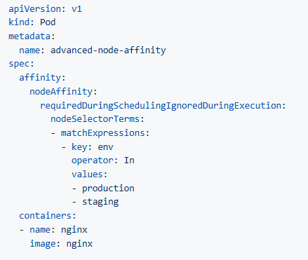

If no node is labelled as production or staging, pod will be in pending state.



Once node is labelled

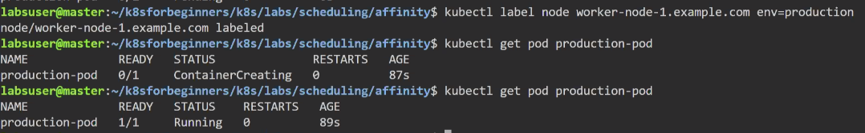

If the node is unlabelled then the still pod will be in running state as it is ignored during execution. If new pod is created then they will be pending state.

preferredDuringSchedulingIgnoredDuringExecution – If option is present will execute else the pod will not be in waiting state and will execute

requiredDuringSchedulingIgnoredDuringExecution – If not present, pod will be waiting

## PriorityClass

To Set priority, need kind PriorityClass

<https://github.com/devopscert202/k8sforbeginners/tree/main/k8s/labs/scheduling/priorityclass>

Providing priority to workloads, if there are 100 pods are scheduled and want to prioritize

Setting priority class

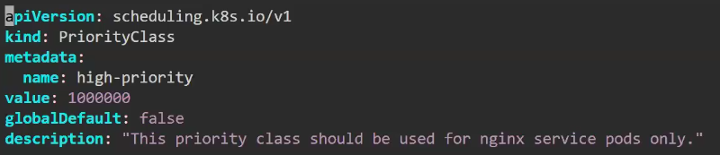

List of priorities in kubernetes

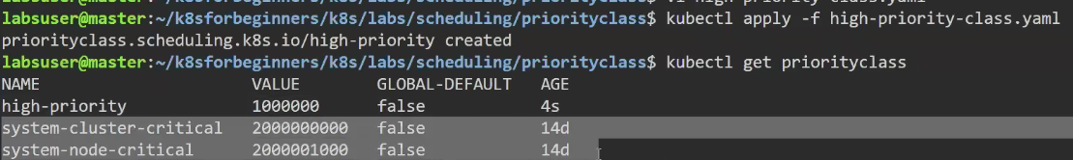

Setting for pod

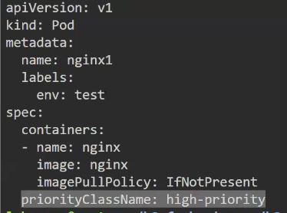

# Networking

Master – worker node connectivity is not based on kube proxy but to join the nods for kubernetes to function

Kubeproxy – Core DNS

Kubelet – node agent

CNI – firewall

Service Endpoints

<https://github.com/devopscert202/k8sforbeginners/tree/59a13cbc243100e60a2f60c57f38231713c2a0c8/k8s/docs/networking>

<https://github.com/devopscert202/k8sforbeginners/tree/59a13cbc243100e60a2f60c57f38231713c2a0c8/k8s/labs/networking>

## Networking Components

<https://github.com/devopscert202/k8sforbeginners/blob/59a13cbc243100e60a2f60c57f38231713c2a0c8/k8s/docs/networking/networking-basics.md>

To setup network need 3 things

1. VM IP Addresses
2. IP Range for worker nodes (CIDR) defines first and last IP Address 192.168.1.1/26 (26 machines) – size of Kubernetes cluster. If its setup in cloud then we need region/Availability Zone/Subnet Range.

To allow communication need to consider

1. firewall (if master and worker node are in same subnet, we don’t need firewall but they may be distributed across multiple availability zone),
2. Security Groups (instance level firewall),
3. VPC (Virtual Private Cloud – network boundary where we setup cluster),
4. Internet Gateway (to reach public internet)
5. NAT Gateway (ingress and egress)
6. DNS
7. Load Balancer (Kubernetes recognize the service spec type LoadBalancer as HTTP L7 load balancer in the cloud)
8. Sadas

2:13:26

Go into the Pod



<https://github.com/devopscert202/k8sforbeginners/blob/59a13cbc243100e60a2f60c57f38231713c2a0c8/k8s/docs/networking/dnspolicy-k8s.md>

Pods running in Kubernetes namespace DNS

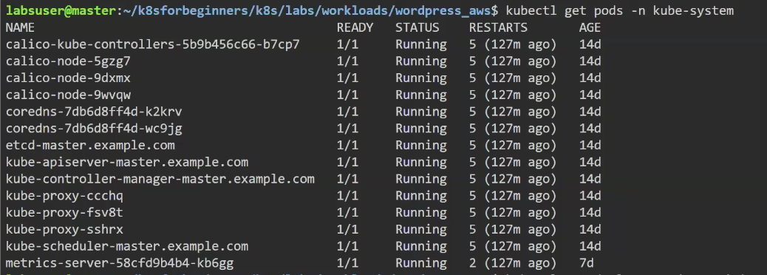

Pods running in coredns



To describe

Kubectl describe pod coredns-<podname> -n kube-system

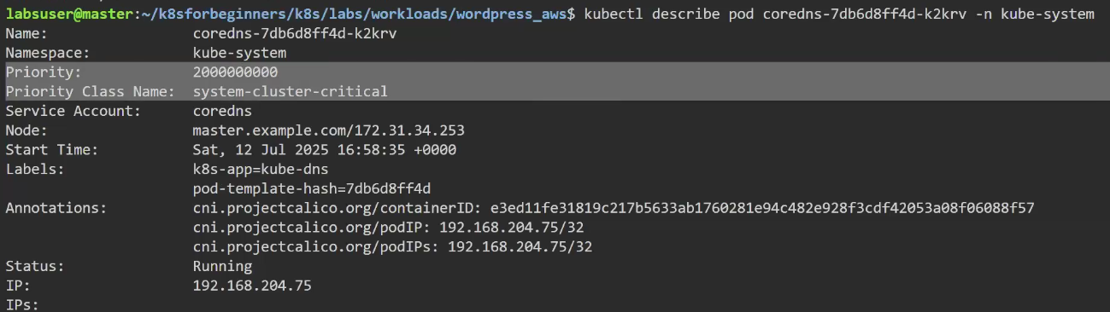

Listing with Labelnames



Checking the service



Getting IPAdress endpoints



Without the pod or deployment yaml file can run pod in command prompt



mysql.default.svc.cluster.local

mysql 🡪 Service Name

default 🡪 Namespace (FQDN is default), another service of same name can be in different namespace

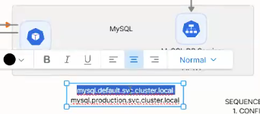

Resolve the IPAddress and trying to connect to the service.

IF not able to connect to any name server, add the nameserver to /etc/resolv.conf

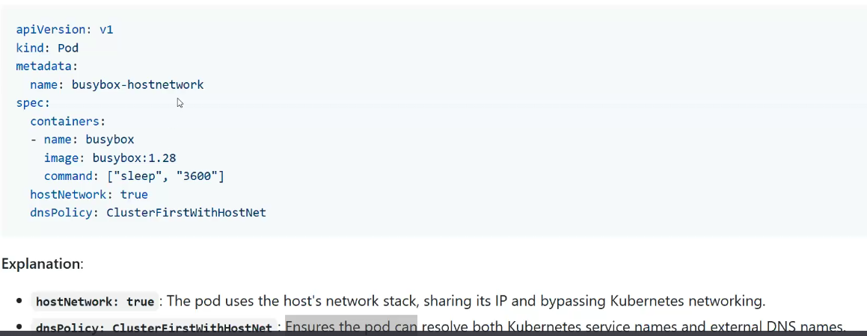

## ingress vs egress

If only the production WordPress to connect to production MySql and to control network traffic flow by network policies by defining virtual firewall.

2 directions network terminology used is ingress and egress

Ingress 🡪 Connection going towards (Incoming request to cloud)

Egress 🡪 anything goes outside (outgoing from cloud)

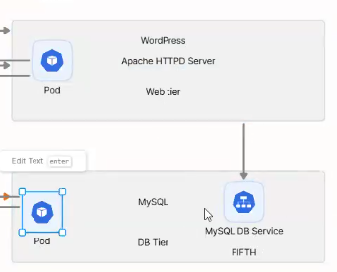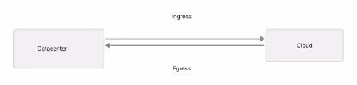

Controlling the network traffic is by ingress and egress.

## Multiport-Service

Same image can have 2 different ports. This will have different websites host in a same server.

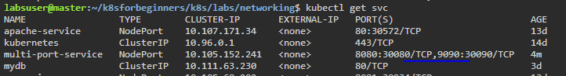

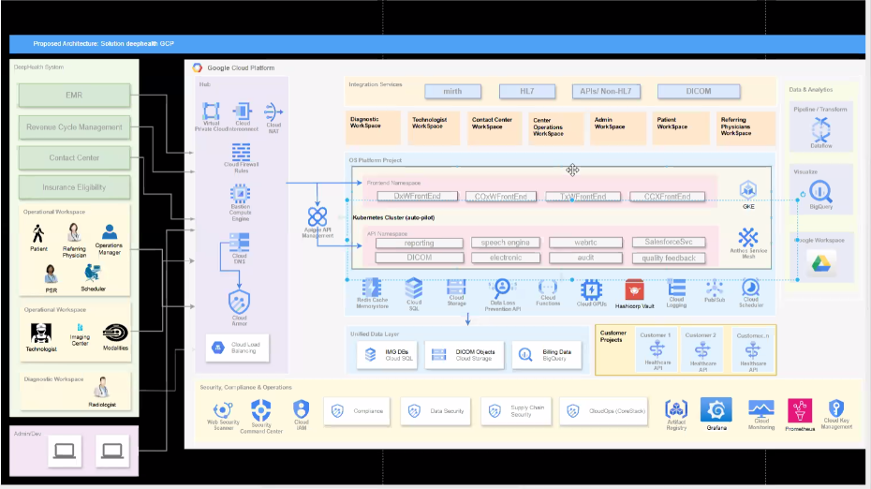

# Security

## SecurityContext

Docs 🡪 <https://github.com/devopscert202/k8sforbeginners/blob/main/k8s/docs/security/securitycontext.md>

<https://github.com/devopscert202/k8sforbeginners/blob/main/k8s/docs/security/networkpolicy.md>

## NetworkPolicy

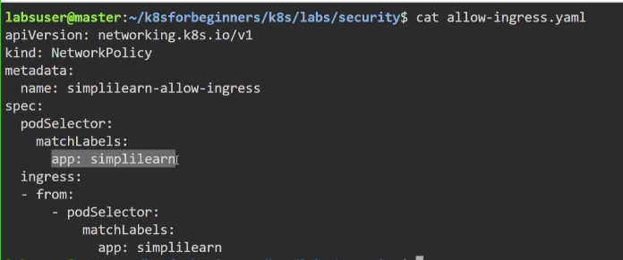

Here app label is simplilearn

Ingress - If incoming connection from app simplilearn then pod will accept the connection.

If the pod not from simplilearn app label then won’t accept connection.

Listing pods



test-27225 can call simplilearn pod as both pods have app label

as per network policy

try this in lab

## DenyFromOtherNamespaces

Here labels not matter, only namespace matters

<https://github.com/devopscert202/k8sforbeginners/blob/59a13cbc243100e60a2f60c57f38231713c2a0c8/k8s/docs/security/networkpolicy-namespace.md>

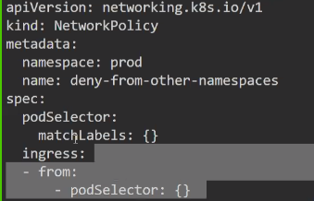



Create pods in default namespace (first one), and test namespace (second one)

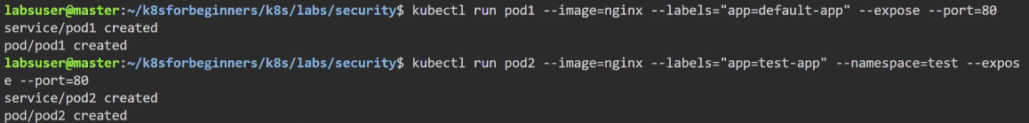

Pod1 – default namespace and pod2 is test namespace, here it is failing as network policy restrict

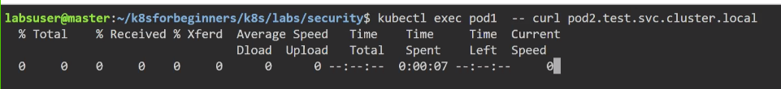

Being in same namespace test, its working fine.

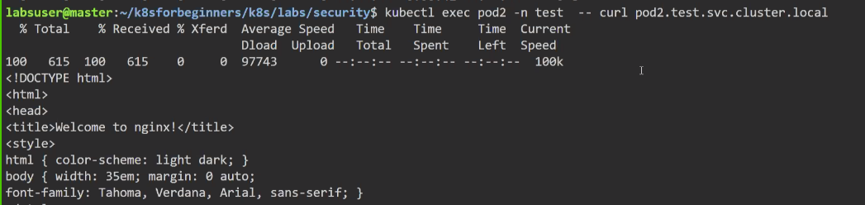

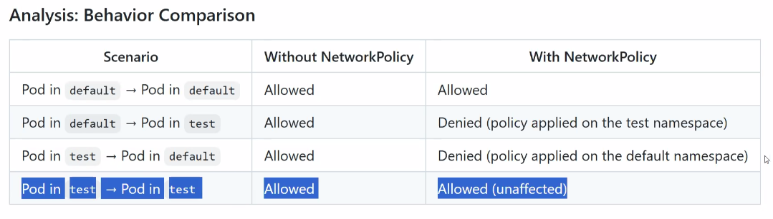

## Kubernetes Vulnerabilities Management

Docs - <https://github.com/devopscert202/k8sforbeginners/blob/main/k8s/docs/security/k8s-vulnerabilities.md>

<https://www.cve.org/> - Has list of vulnerabilities. If the CVEs are unattended then will be a big issue.

### Container Security

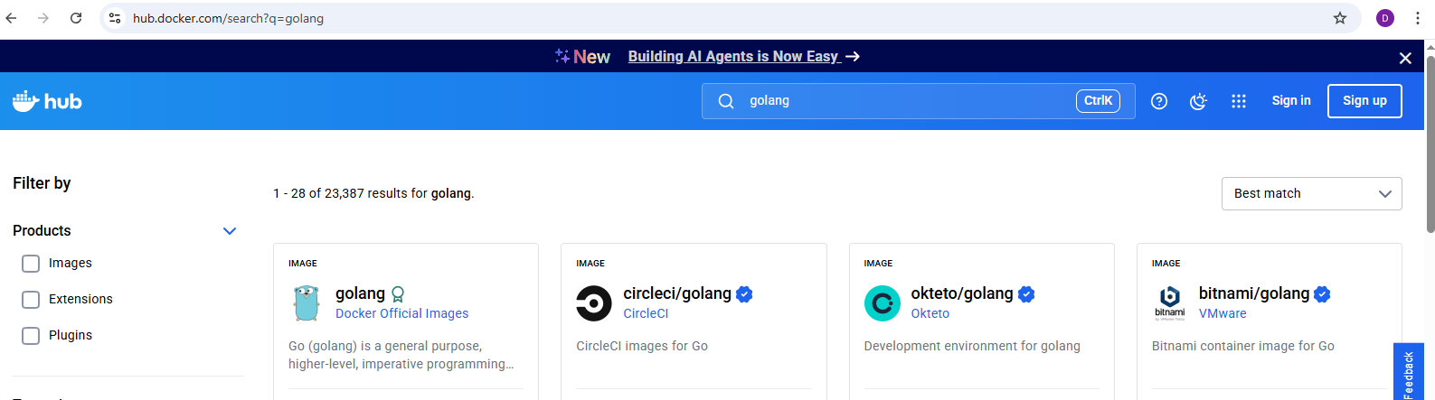

For Kubernetes, taking the image from docker. Not all images are not free from vulnerabilities. All container security.

### Platform Security

All the containers are running in nodes. All commands as kubectl, namespace, labelling etc are to be secured.

Always have n-1 version of any OS or Software etc

If cluster is in latest version and OS older version then its vulnerable and compromised.

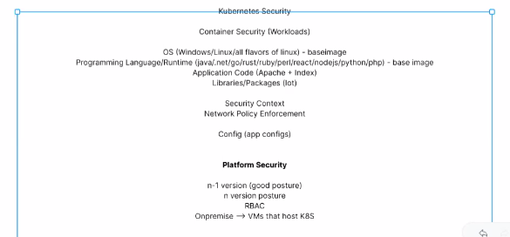

## Demo

<https://github.com/devopscert202/k8sforbeginners/blob/main/k8s/labs/security/image_scanning.md>

# Storage

## Persistent Storage

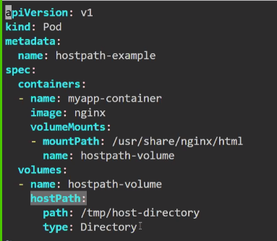

<https://github.com/devopscert202/k8sforbeginners/blob/main/k8s/docs/storage/k8s-storage.md>

<https://github.com/devopscert202/k8sforbeginners/blob/main/k8s/docs/storage/k8s-storage-design.md>

<https://github.com/devopscert202/k8sforbeginners/blob/main/k8s/docs/storage/k8s-storage-part2.md>

Hostpath-volume is mounted to /tmp/host-directory

Will be deployed to the directory /tmp/host-directory

If directory is not available then pod will not be created

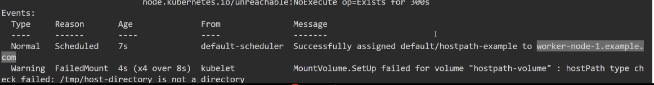

On creating the directory in worker node,

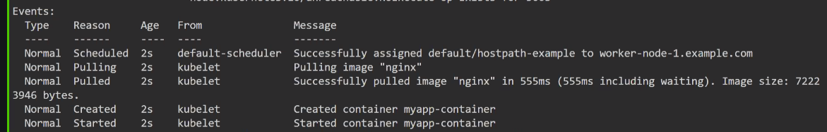

On creating a file in the worker node /tmp/host-directory

On going to the pod hostpath-example, inside pod the contents are shown

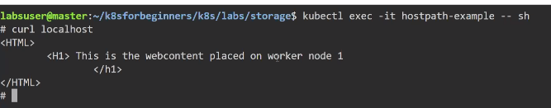

On deleting the pod, still the file will be present

If again the pod is created, under the pod location /usr/share/nginx/html, index.html is present

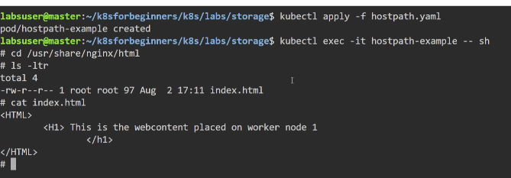

If the index file is changed in worker node, will be available in pod.

## Sharing Data

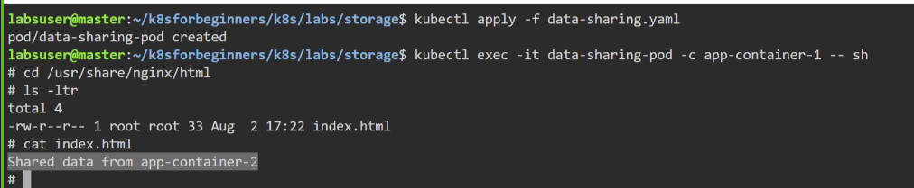

<https://github.com/devopscert202/k8sforbeginners/blob/main/k8s/docs/storage/sharingdata.md>

## Secrets in Volume

<https://github.com/devopscert202/k8sforbeginners/blob/main/k8s/docs/storage/secret-volume.md>

<https://github.com/devopscert202/k8sforbeginners/blob/main/k8s/docs/storage/k8s-storage.md>

## More about Storage

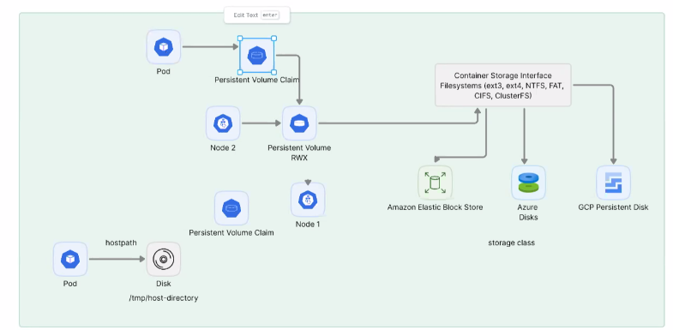

<https://github.com/devopscert202/k8sforbeginners/blob/main/k8s/docs/storage/k8s-storage.md>

<https://github.com/devopscert202/k8sforbeginners/blob/main/k8s/docs/storage/k8s-storage-design.md>

<https://github.com/devopscert202/k8sforbeginners/blob/main/k8s/docs/storage/k8s-storage-part2.md>

<https://github.com/devopscert202/k8sforbeginners/blob/main/k8s/labs/storage/hostpath-pv-pvc.yaml>

Kubernetes no need to know about the file system of Windows, Linux, Cloud

Robust way is Persistent volume and persistent volume claim.

Persistent volume – Create a file system ie define the storage space

Persistent volume claim – Who is going to claim. If params are matching then claim will store the data. Pod don’t need to know about the persistent volume and it just claim the allocated space.

If any change in the filesystem, pod is not going to know about the change.

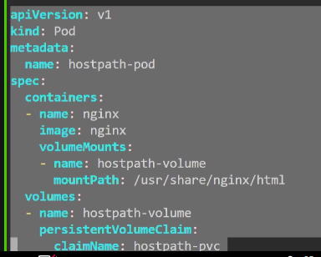

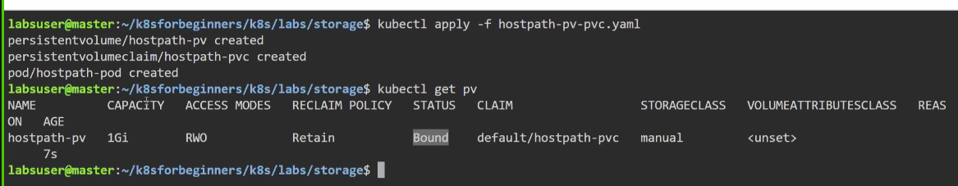

Status – Bound.

If pod is not claimed then status is not bound.

# Upgrade Kubernetes

<https://github.com/devopscert202/k8sforbeginners/tree/main/k8s/docs/upgrade>

<https://github.com/devopscert202/k8sforbeginners/blob/main/k8s/docs/upgrade/k8s-skewpolicy.md>

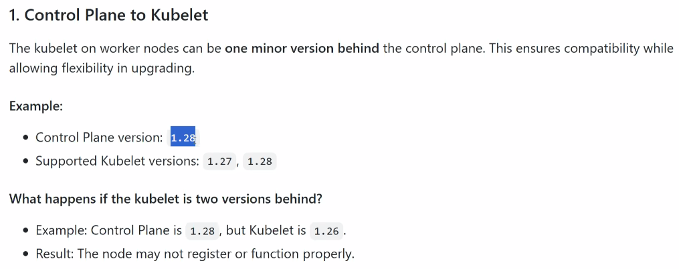

Supported version should be 1 version older. Control Plane and Kubelet version should be matching or at least 1 version behind. If more than that, commands will behave weird.

### Upgrade into master

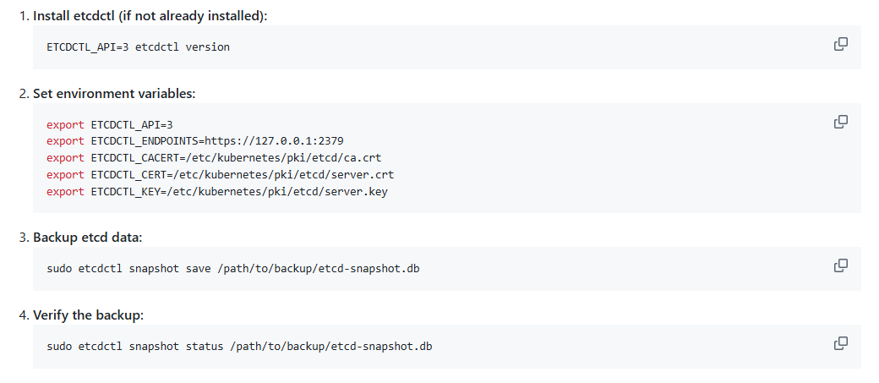

curl -fsSL https://pkgs.k8s.io/core:/stable:/v1.29/deb/Release.key | sudo gpg --dearmor -o /etc/apt/keyrings/kubernetes-apt-keyring.gpg

echo 'deb [signed-by=/etc/apt/keyrings/kubernetes-apt-keyring.gpg] https://pkgs.k8s.io/core:/stable:/v1.31/deb/ /' | sudo tee /etc/apt/sources.list.d/kubernetes.list

sudo apt-get update

apt-cache madison kubeadm

Says what all available minor versions in 1.31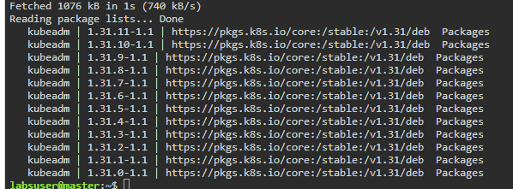

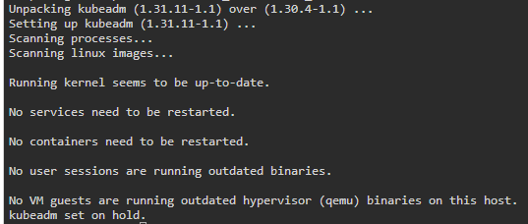



But still kubectl version is same as older

sudo kubeadm upgrade plan

will show the options

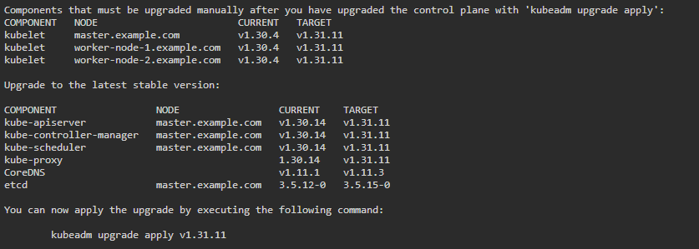

Then upgrade using same command (use sudo)

But still kubectl is older version

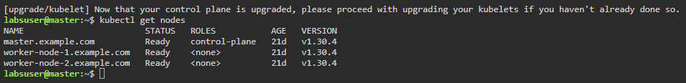

sudo kubeadm upgrade apply v1.31.11



kubectl drain <control-plane-node> --ignore-daemonsets

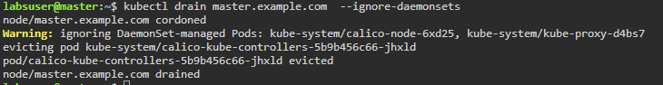

sudo apt-mark unhold kubelet kubectl

sudo apt-get install -y kubelet=1.29.12-1.1 kubectl=1.29.12-1.1

sudo apt-mark hold kubelet kubectl

Will restart the services

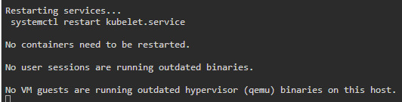

### Worker Node

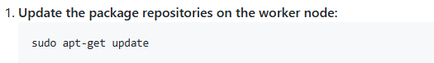

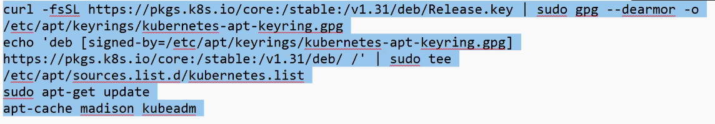

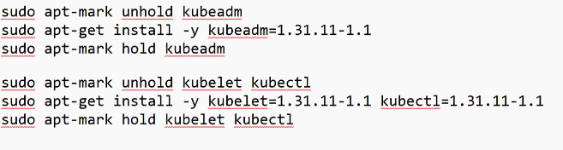

# Setup in GCP Account

Google Cloud Account

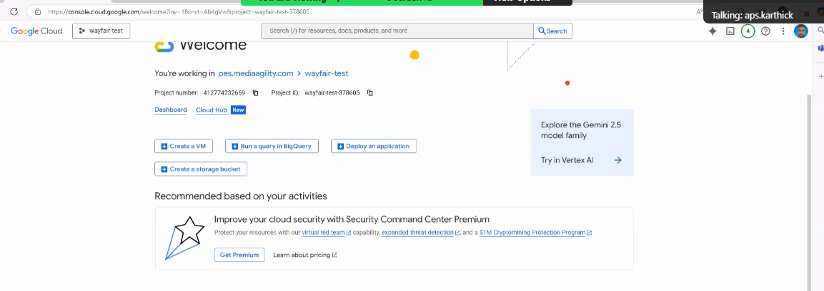

Has one cluster by name gke-demo present in us-east4 region. Has 3 nodes has each 8 GB for memory

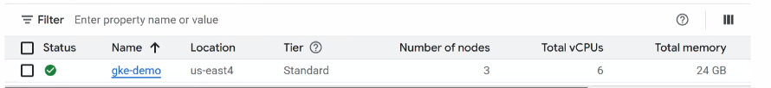

All running in 3 availability zones

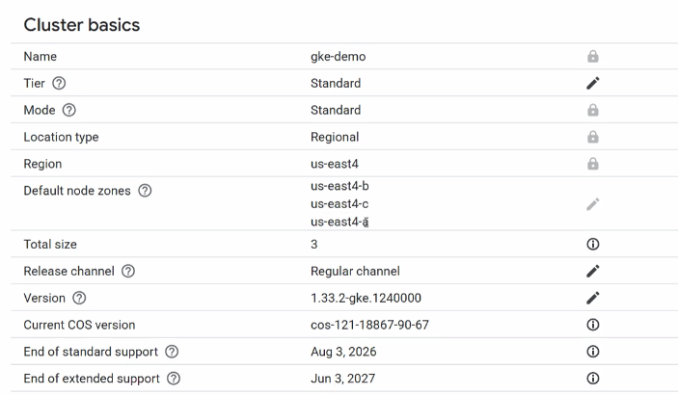

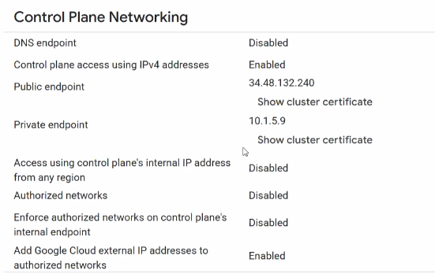

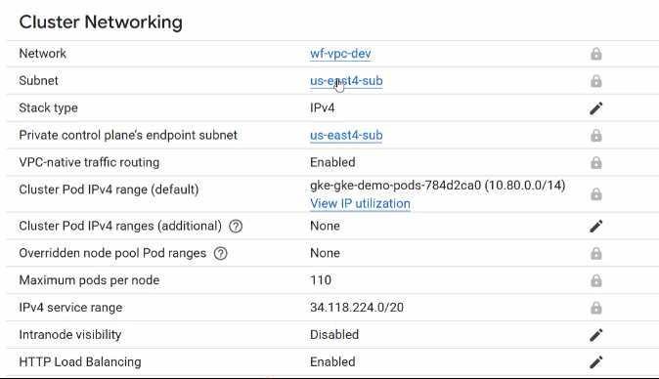

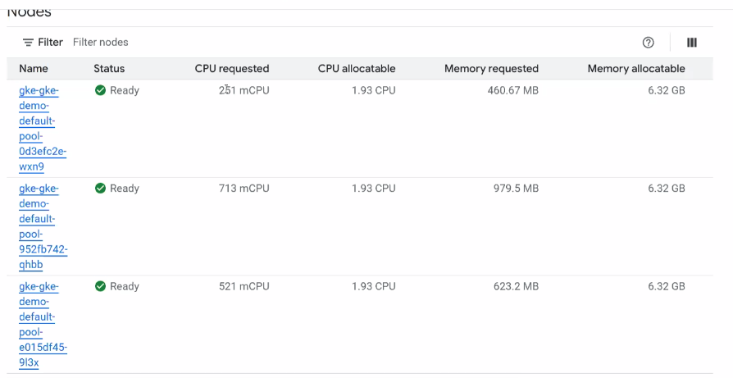

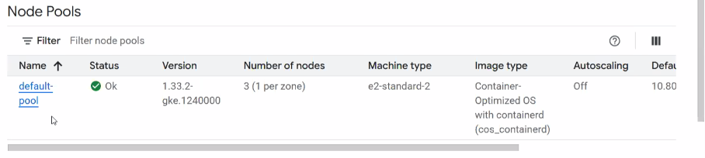

# Kubernetes Troubleshooting

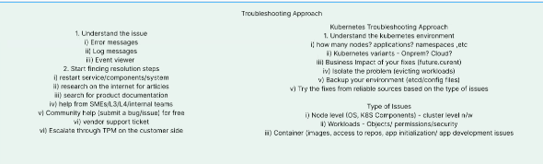

Get to know the kubeadm



Get to know the cluster info

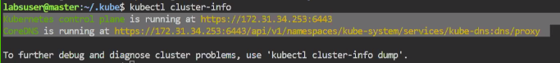

Kubectl cluster-info dump > any file

In master node, .kube file will be present which has config file

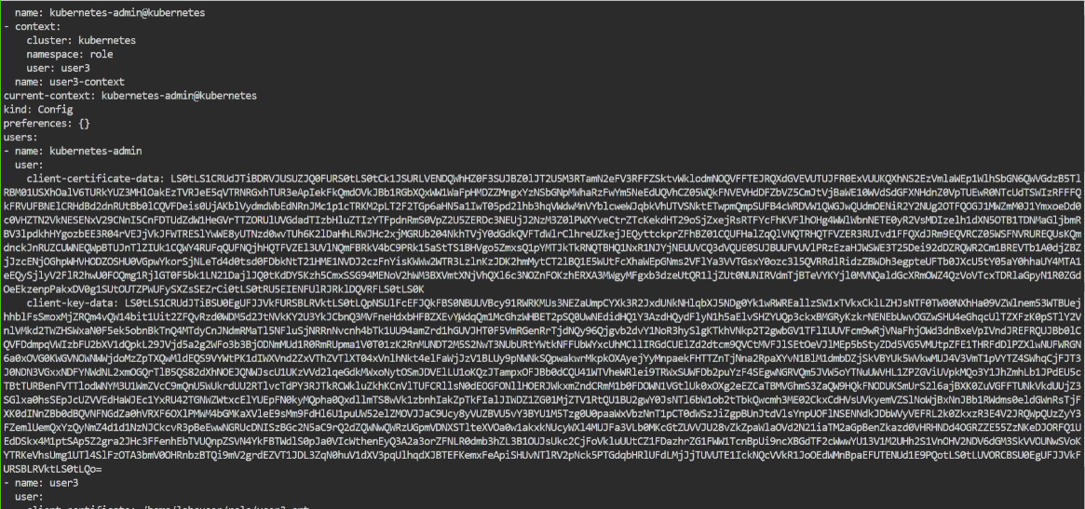

If node to run kubectl command, create .kube directory and copy config file from master node. And still worker node as worker node and master node as master node.

kubectl get pods –all-namespaces

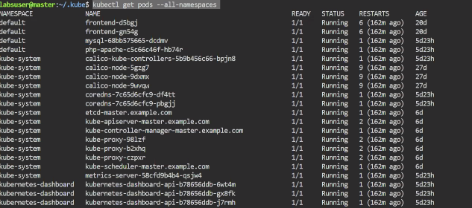

Check for get nodes, If any worker node is not running fine,

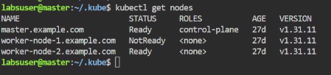

Execute, kubectl describe get node <node-name>

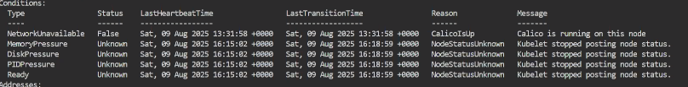

Go to worker node, execute some commands

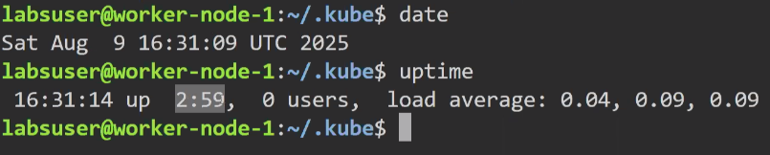

sudo systemctl status kubelet

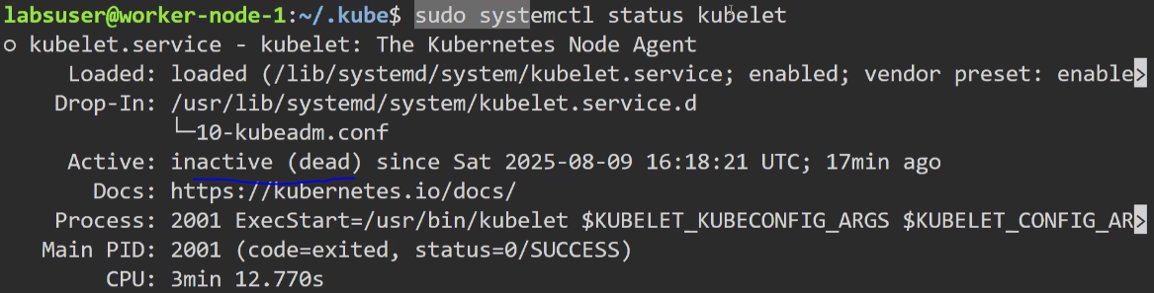

sudo systemctl start kubelet 🡪 start service

kubelet is not shown as its part of linux command

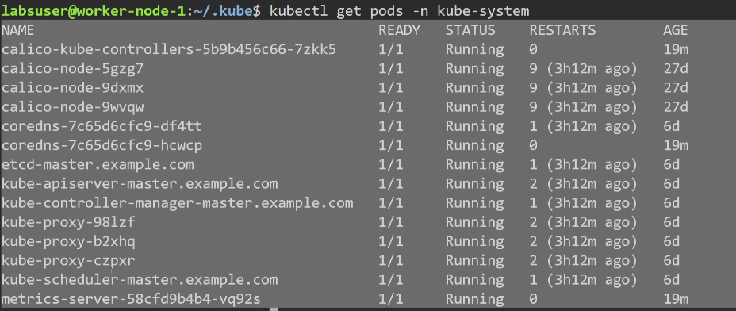

Create a pod



kubectl describe pod testing

if no events

kubectl logs testing, can be no logs

sudo crictl pods 🡪 Utility name

sudo systemctl restart containerd

test create pod with creating with different image

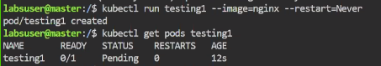

kubectl get pods –all-namespaces





Instead of pointing to scheduler.conf, scheduler.conf_tmp is being pointed.

Check for manifest directory

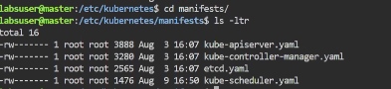

Check kube-scheduler.yaml

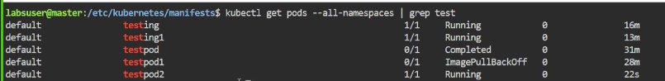

<https://github.com/devopscert202/k8sforbeginners/tree/main/k8s/docs/troubleshooting>

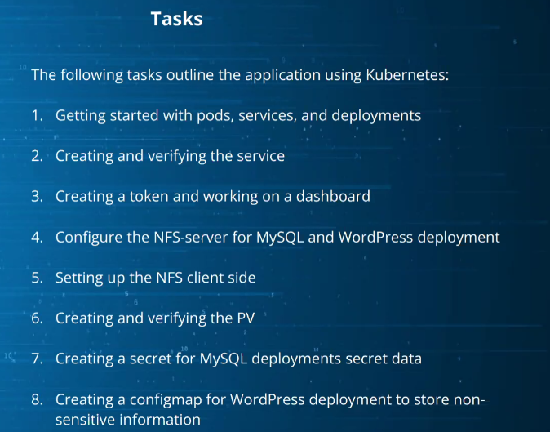

# Kubernetes Setup in GKE

Cloud based applications has good advantages

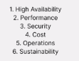

<https://console.cloud.google.com/>

<https://github.com/devopscert202/k8sforbeginners/blob/main/k8s/labs/gcp/gke_intro.md>

Cluster Creation

gcloud container clusters create gkedemo1 --zone=us-east4 --machine-type e2-standard-2 --network=wf-vpc-dev --subnetwork=us-east4-sub

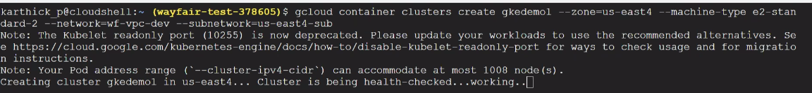

gcloud container clusters get-credentials gkedemo1 --zone=us-east4



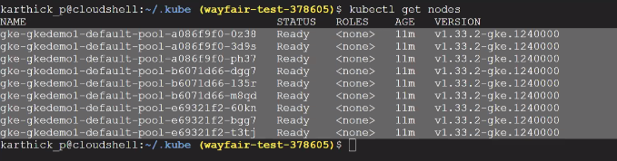

gcloud beta container --project "able-plating-468614-g4" clusters create-auto "gkedemo1" --region "us-east1" --release-channel "regular" --tier "standard" --enable-ip-access --no-enable-google-cloud-access --network "projects/able-plating-468614-g4/global/networks/default" --subnetwork "projects/able-plating-468614-g4/regions/us-east1/subnetworks/default" --cluster-ipv4-cidr "/17" --binauthz-evaluation-mode=DISABLED

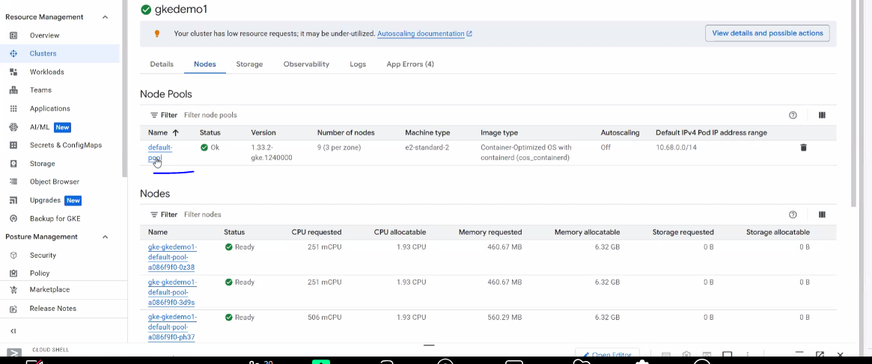

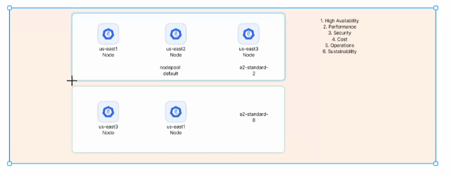

gcloud container clusters get-credentials gkedemo1 --zone=us-east1



L1 - Physical, L2 - Data, L3 - Network, L4 - Transport, L5 - Session, L6 - Presentation, and L7 – Application

Deploy default L7 Loadbalancer layer

kubectl config current-context



Use Deployment and Service from the location - <https://github.com/devopscert202/k8sforbeginners/tree/main/k8s/labs/aws>

Git Clone

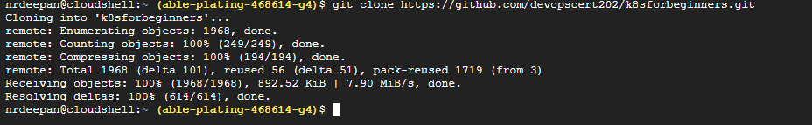

Deploy deployment and services from /k8sforbeginners/k8s/labs/aws

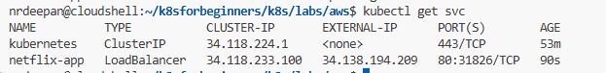

On navigating into external-ip

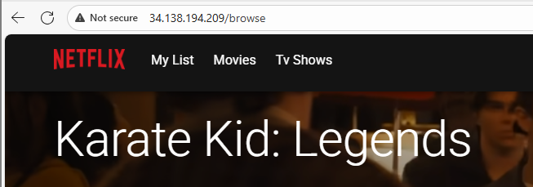

Navigate to Overview >> Kubernetes Engine >> Overview

Also Overview >> Kubernetes Engine >> Clusters to view clusters

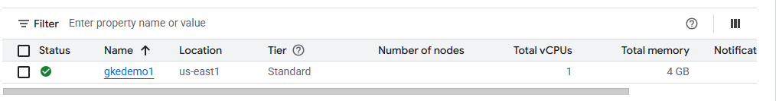

Overview >> Kubernetes Engine >> Workloads to view Service, Pods, Deployments

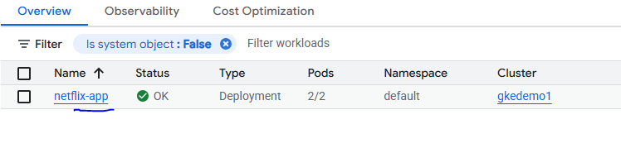

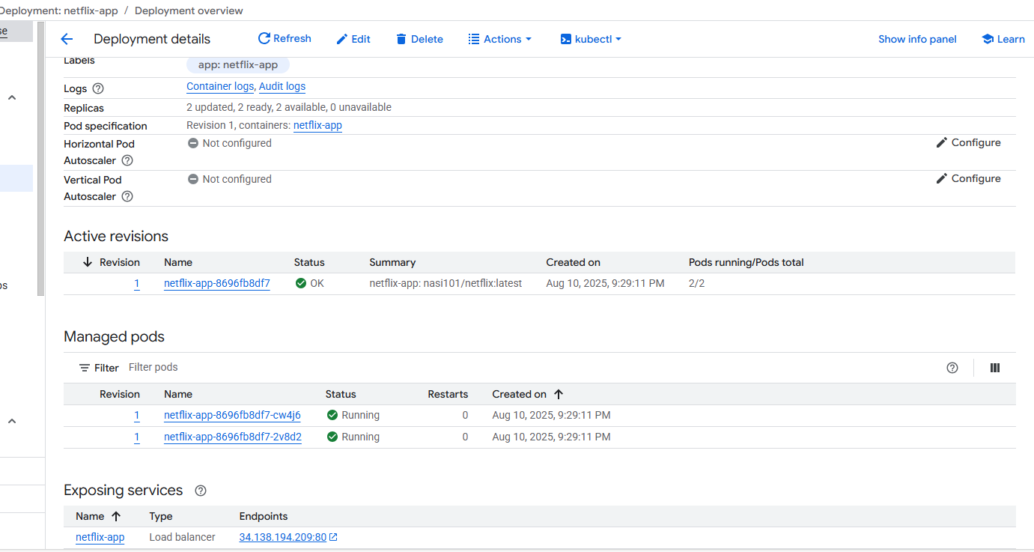

Don’t forget to delete the cluster Before November 1st.



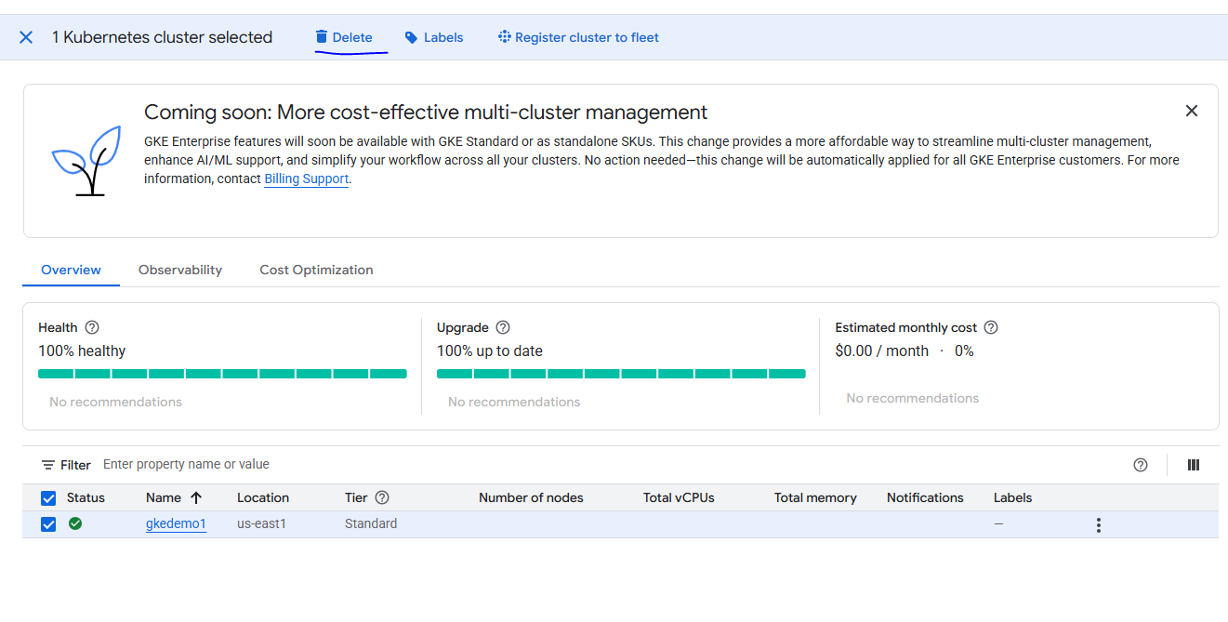

# e-Commerce Application

<https://github.com/devopscert202/k8sforbeginners/tree/main/k8s/labs/ecommerce-app>

Go to the location k8sforbeginners/k8s/labs/ecommerce-app/frontend

docker build -t ecommerce-app:1.0 .

This generates the image into local folder.